ATIC Accessibility

To support the accessible community in making informed travel decisions for their individual needs

This report prepared for:

|  |  |
| --- | --- |
| Business name: | Greater Shepparton City Council / Greater Shepparton Visitor Centre |
| Address: | 530 Wyndham Street |
| Town: | Shepparton |
| Contact for enquiries: | Maree Glasson |
| Contact Number: | 0358329330 |
| Contact Email: | maree.glasson@shepparton.vic.gov.au |
| Website: | https://sheppandgv.com.au/see-and-do/greater-shepparton-visitor-centre |
| Date: | 2025-08-15 12:54 |

ATIC Accessibility

The following pages provides travellers with information on the businesses facilities and amenities which aims to support the traveller to make an informed decision on whether the business is suitable for their individual needs.

OVERVIEW 4

Business Overview 4

Bookings 4

Emergency Management 4

Communications 5

Other Information 6

Guide Dog and Service Animals 6

GENERAL 7

Pre-arrival, arrival and reception 7

Cognitive Impairment Support 7

Car Park and Access amenities 7

Entry 8

Internal Spaces 8

Public areas 9

External Paths 9

Public Toilets/Adult change facilities 9

COMMON AREAS 10

Report Disclaimer 12

# OVERVIEW

## Business Overview

The business has the following products/services available

Our business caters for the following disability types:

* Blind or low vision
* Deaf or low hearing
* Limited mobility
* Wheelchairs or mobility scooters
* Cognitive or people on the Autism Spectrum



## Bookings

The business offers the following methods for bookings and enquiries:

* Phone
* Email
* Webportal
* Our website supports Screen Readers
* Our forms have high contract boxes and submit boxes
* Staff have undergone disability awareness and training

## Emergency Management

Visitors attending the visitor centre are only onsite for a short time, and are always within eye sight of staff and volunteers.

* There are Audible device/s to alert occupants to evacuate with instructions on how to evacuate.
* There are visual device/s to alert occupants to evacuate.
* Exit signs are clear and easy to see
* Exit access is free and clear at all times

We ensure exit access is free and clear at all times by:

The exit access is the main entry. This is checked to ensure clear on a regular basis, as it not only impacts during an emergency, but also would impact day to day business if it wasn't clear.

* Exits and access to exists are greater than 900mm
* Exit doors are able to be opened by all occupants
* Exits to the emergency evacuation point does not include stairways
* The evacuation point is clearly marked by a sign

The business identifies guests who need additional assistance should an emergency occur by:

As staff are checking the Centre is clear, visitors are communicated with to ensure everyone is able to evacuate the building safely.

The procedure for assisting guests who need assisted rescue is:

Staff check with visitors, and if assistance is required that is beyond what is manageable by staff, then they communicate the needs to emergency services when they arrive.

## Communications

* An accessibility guide is available on the website

https://sheppandgv.com.au/listing/accessibility-in-shepparton--goulburn-valley-1203

* Our website meets WCAG 2.0 accessibility standards
* Our business offers the following alternative communication methods
* Plain English
* Magnifiers

Communication boards and Alphabet boards displayed and readily accessible.

* There is easy to read signage and information (e.g. menus and emergency information)
* There are Picture boards

Picture Boards Image(s)

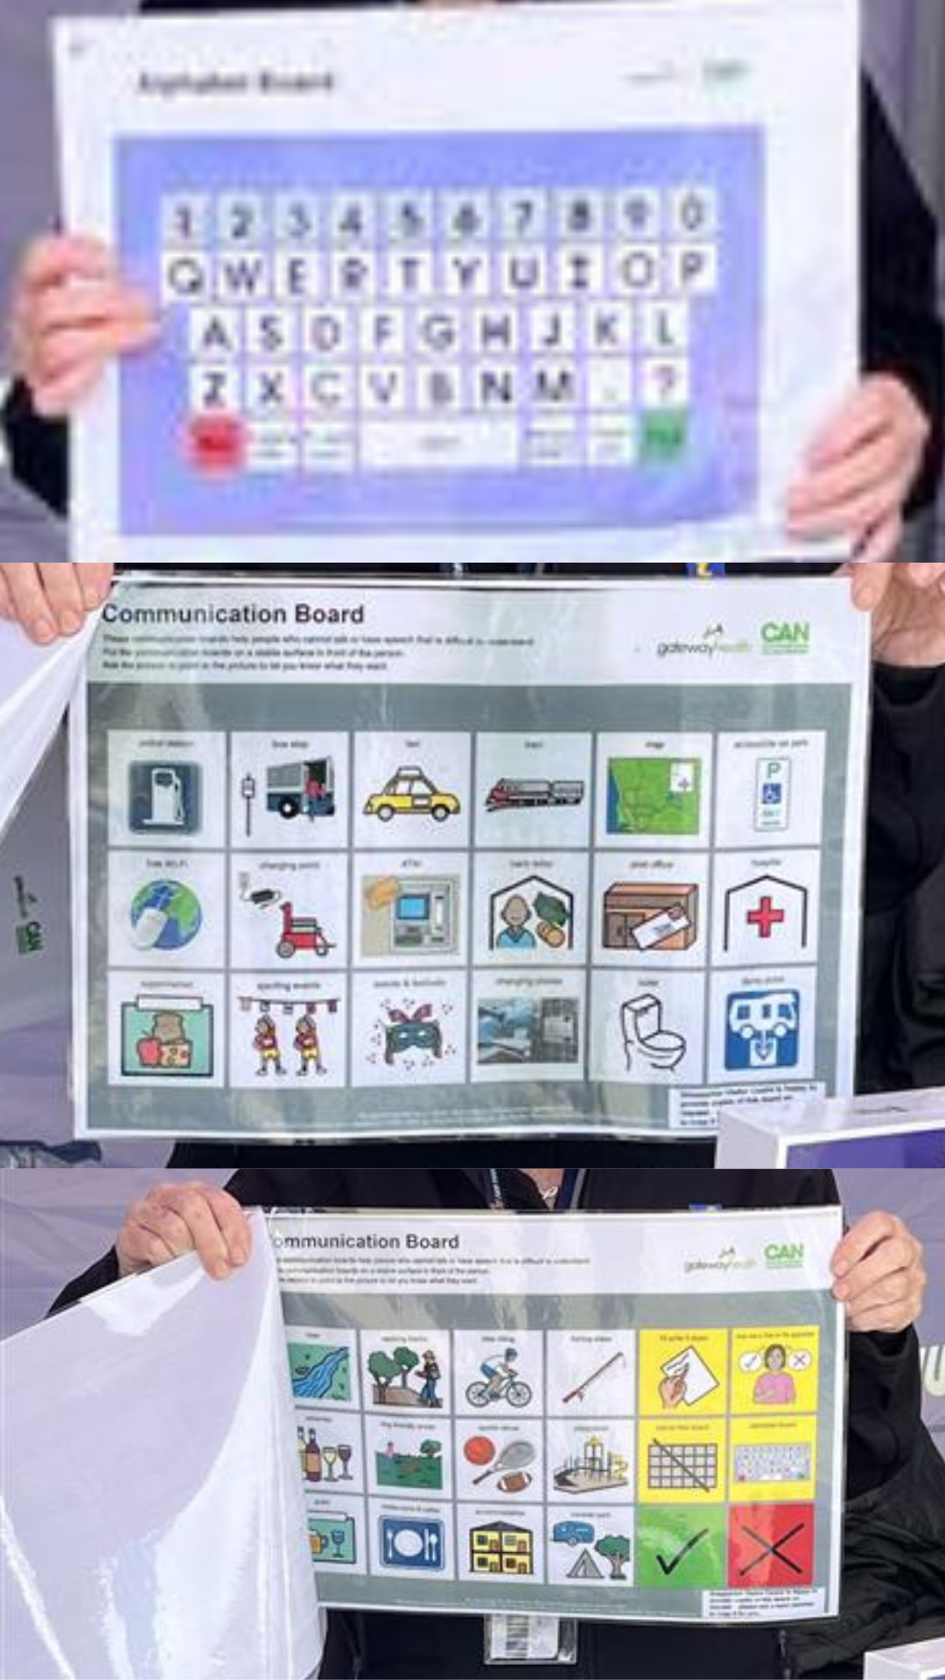

Communication boards and Alphabet Board available at the Visitor Centre

## Other Information

* The business accepts the companion card

## Guide Dog and Service Animals

* The business provides a secure area with shade and water for service animals

The business provides the following services for services animals:

The Visitor Centre provides a dog water bowl at the main entrance.

# GENERAL

## Pre-arrival, arrival and reception

The business has the following in place to support guests during pre-arrival, arrival and reception

* Booking information and websites are compatible with screen readers
* Advertising material, web sites and social media contain information relating to phone numbers available for non-voice communication e: Text, SMS, email and fax
* A key to any accessible facilities that are locked
* In addition, the following further information can assist guests:

Chairs and couches are available for visitors throughout their visit.&nbsp;

* In addition, the following further information can assist guests:

Whilst the Centre doesn't offer a familiarisation tour of the centre as such, each guest is greeted by a friendly staff member of volunteer who guides them to the various sections of information.

## Cognitive Impairment Support

* Documents are available in plain English for people with cognitive impairment (This may include instructions, guides, menus and general information)
* A space for parents and children on the Autism Spectrum

## Car Park and Access amenities

The business has the following Car Park and Access amenities

* A drop off zone
* Designated disabled parking bays
* Level or ramped access from the car park to the entrance
* The accessible entrance is clearly signed from the parking bay
* Kerb ramps are in place where a pavement or walkway needs to be crossed
* In addition, the following further information can assist guests:

There is a large driveway loop at the front of the Visitor Centre, with a drop off point and two accessible parking spaces. Additional accessible parking spaces are provided in the main carpark. The Centre has two couches, tables and chairs, with colour in pictures available for those who wish to to have some quiet time.&nbsp;

## Entry

The business has the following amenities/systems in place for entry

* A drop off point close to the entrance
* A path of access to the building is slip resistance and even
* A path of access to the building is clear of obstruction
* Self opening entry doors or fitted with a self closer
* Glass doors are fitted with a visual sighting strip
* Door jams/doors are of a contrasting colour to surrounding walls
* Door handles are of a contrasting colour to the door
* Signage is written in a contrasting colour
* The entry door is a minimum of 850mm wide
* The entry door has self opening or a light opening pressure (for manual operations)
* The entrance sill is less than 13mm
* There a clear space of at least 1500mm x 1500mm in front of all doors.
* The entrance door mats have a thickness less than 13mm and a width of 7500mm or greater
* In addition, the following further information can assist guests:

All signs use Sans Serif fonts, however some signage is in all uppercase.&nbsp;

* In addition, the following further information can assist guests:

There is no lift within the Visitor Centre, however there is one within the SAM Precinct for access to the Art Museum and Cafe.&nbsp;

## Internal Spaces

* Clear and unobstructed routes through and between buildings
* Interior walls are matte or low sheen
* Floors, walls, counters and furniture are of contrasting colours
* Floor surfaces are hard or short pile carpet
* Seating is available for guests unable to stand for long periods
* Accessible facilities are clearly signed and visible from all areas
* All corridors greater than 900mm
* There is a quiet space for parents and children on the Autism Spectrum
* In addition, the following further information can assist guests:

The Centre is its quietest on Tuesdays when the Art Museums and Cafe are closed. If you are looking to avoid busy times, the Centre is its busiest on weekends and lunchtimes.

## Public areas

The public areas have the following amenities in place

* Display units, Televisions, Video displays etc. are open captioned
* Hearing loops
* Hearing loop symbols are displayed
* Even lighting
* Seating
* In addition, the following further information can assist guests:

Two couches, and additional seating is provided inside the light, bright, open visitor centre.&nbsp;

## External Paths

External paths of travel have the following amenities are in place

* Surfaces are concrete, asphalt, smooth paving or hard packed fine gravel (max aggregate size 13mm)
* Pathways are wider than 900mm
* There 3 successive steps or less on any path or at any doorway

There aren't any paths with steps around the Visitor Centre

## Public Toilets/Adult change facilities

Public Toilets/Adult change facilities have the following amenities are in place

* There is an accessible toilet for public use
* The door is at least 850mm wide
* There is a minimum of 850mm beside the toilet
* Handrails are fitted
* The toilet seat is 460mm above the floor
* The toilet seat of a contrasting colour to the floor
* The toilet seat is460mm above the floor
* There is a registered changing places facility
* There is a 'Changing Place' within 35m of our business
* In addition, the following further information can assist guests:

The Visitor Centre has a MLAK key for access to the changing places facility.

# COMMON AREAS

## Report Disclaimer

Please note that this business report, provided as a result of the use of the diagnostic assessment, is for information purposes only.

Australian Tourism Industry Council (ATIC) cannot guarantee the accuracy of respondent’s answers, or that they are fully representative of your business. Therefore, ATIC does not warrant or guarantee any particular outcome in respect of your businesses self-assessment.

This report is intended as guidance only for your business and should not be relied on for future marketing considerations. ATIC recommends that you seek your own independent advice as well as the results from the diagnostic.

Links to external web sites are inserted for convenience and do not constitute endorsement of material at those sites, or any associated organisation, product or service.

ATIC does not:

1. Assume any legal liability for the accuracy, completeness, or usefulness of any information from this report or any links provided; or
2. Accept responsibility for any loss associated directly or indirectly from the use of this report.